**Title:** The contribution of violence to life uncertainty on a global scale

**Authors:**

*José Manuel Aburto. Interdisciplinary Centre on Population Dynamics at University of Southern Denmark, Odense 5000, Denmark, and Max Planck Institute for Demographic Research, Rostock 18057, Germany.

Tim Riffe. Max Planck Institute for Demographic Research, Rostock 18057, Germany.

Vanessa di Lego. Wittgenstein Centre (IIASA, VID/ÖAW, WU), Vienna Institute of Demography / Austrian Academy of Sciences, Vienna, Austria.

Orsola Torrisi. London School of Economics, London, UK.

*Corresponding author.

**Abstract [150]:**

**Main text [3500]:**

Uncertainty about the future, and mortality in particular, is a fundamental condition of human life and key in shaping people’s behaviour. Any individual making choices over her/his lifetime must do so, somehow, subject to uncertainty about when death will happen. Most research on uncertain lifetimes, or lifespan inequality, has focused on how this unpredictability affects individual consumption and distribution of wealth.1-5 While, more recently, research on how social determinants, such as socioeconomic status, education or income, affect lifespan uncertainty has found that socially disadvantaged groups tend to experience higher uncertainty about their eventual death.6-11 In contexts of high violence, greater uncertainty in life suggests ineffectiveness of policies to protect individuals and implies a failure of social protection through which violence is spread in a population.12 Our article, therefore, highlights the role of violent environments on lifetime uncertainty.

Globally, lifetime uncertainty varies considerably between countries.13-19 Greater uncertainty usually corresponds to those countries with lower life expectancy.17-19 Since the 18th century, major decreases in lifespan uncertainty came about from reducing premature mortality. This mainly as a result of mortality improvements in infancy, and decreasing infectious diseases and maternal mortality.20 More recently, reduced cancer mortality has helped to make length of lives more equal in developed countries.20,21 However, detailed knowledge is lacking about whether and how violence – a fundamental state of vulnerability – makes lifetimes uncertain. Studies on how violence affects the quality of life often rely on subjective measures.22 Fear of crime, for example, depends on how individuals perceive their environment and, therefore, might lead to a mismatch between the real uncertainty and how it is perceived.23 For instance, females are more likely to report significant levels of vulnerability, while experiencing lower levels of victimization in periods when violence is increasing.24 Certainly, this has an immediate effect on quality of life,25 causing higher levels of stress, anxiety and other mental health issues for individuals,26 while promoting segregation at the population level.24,27 Therefore, more comprehensive understanding of the burden of violence on lifespan uncertainty holds potential insights for the consequences it poses on individuals and societies, their behaviour in violent environments, and the future of longevity.

Here we unify lifetime uncertainty with violence and pose four questions aimed at filling this knowledge gap: How uncertain lifetimes are in the most dangerous countries in the world, compared with peaceful countries, for males compared with females, and what is the contribution of violent deaths to the observed differences? To answer these questions, we use mortality data from 163 countries from the Global Burden of Disease Study (GBD) by sex (3072 life tables),28 and information on levels of violence from the Global Peace Index (GPI) for the period 2008-2017.

**Lifetime uncertainty and violence around the globe**

The level of violence in a country is determined by the Global Peace Index (GPI).29 This index ranks the peacefulness of 163 (99.7% of the global population) countries based on three domains: 1) Ongoing domestic and international conflict, 2) societal safety and security, and 3) militarization. It is constructed with 23 indicators of violence, such as number and duration of internal conflicts, level of perceived criminality, and homicide rates.29 Europe has consistently been the most peaceful region in the world over the last decade. By 2017, the most peaceful nations were Iceland, New Zealand, Portugal, Austria and Denmark. Conversely, the Middle East and North Africa (MENA) are in the other side of the spectrum as the most violent regions,29 and Latin America with highest homicide rates in the world (Figure 1A).30 Syria, Afghanistan, Iraq, South Sudan and Yemen, in particular, were ranked as the most dangerous countries. These countries have all been embroiled in bitter and multifaceted civil wars, inflicting a disproportionate toll on civilians.31-33 In Latin America, Colombia, Venezuela and Mexico were the countries with the highest levels of violence. Venezuela and Mexico have undergone an unprecedented rise in homicides in the last decade due to political conflict and the war on drugs, respectively.12,30,34 While Colombia has historically been a country with high homicide rates, even though homicides have declined since 1996.30

Lifetime uncertainty can be measured with a summary indicator of how similar ages at death are. Multiple indicators exist for this purpose35. These include the standard deviation or the Gini coefficient of the age-at-death distribution. We chose the standard deviation conditioned on surviving to age 10 to determine how spread ages at death are. The high correlation between these indices suggests that our results would not change significantly with the use of another index.14,35 In Syria, Iraq, El Salvador, South Africa and Venezuela, lifetime uncertainty is extraordinarily high for males and females (Figure 1B, see Supplementary Material [SM] for females). This set of countries also shares the highest levels of violence. Syria has been for the past five years the most dangerous country in the world, while El Salvador has presently the second highest homicide rate. In contrast, lifetime uncertainty is remarkably low in most countries of Northern and Southern Europe, where we also observe minimal to low levels violence. The only slightly more peculiar cases are those of Italy, the United Kingdom and Tunisia, where lifespan uncertainty is low, but violence ranges to moderate to middle levels, allegedly due to more regionalised episodes of violence.

**Figure 1 Global level of violence and lifetime uncertainty for males in 2017**

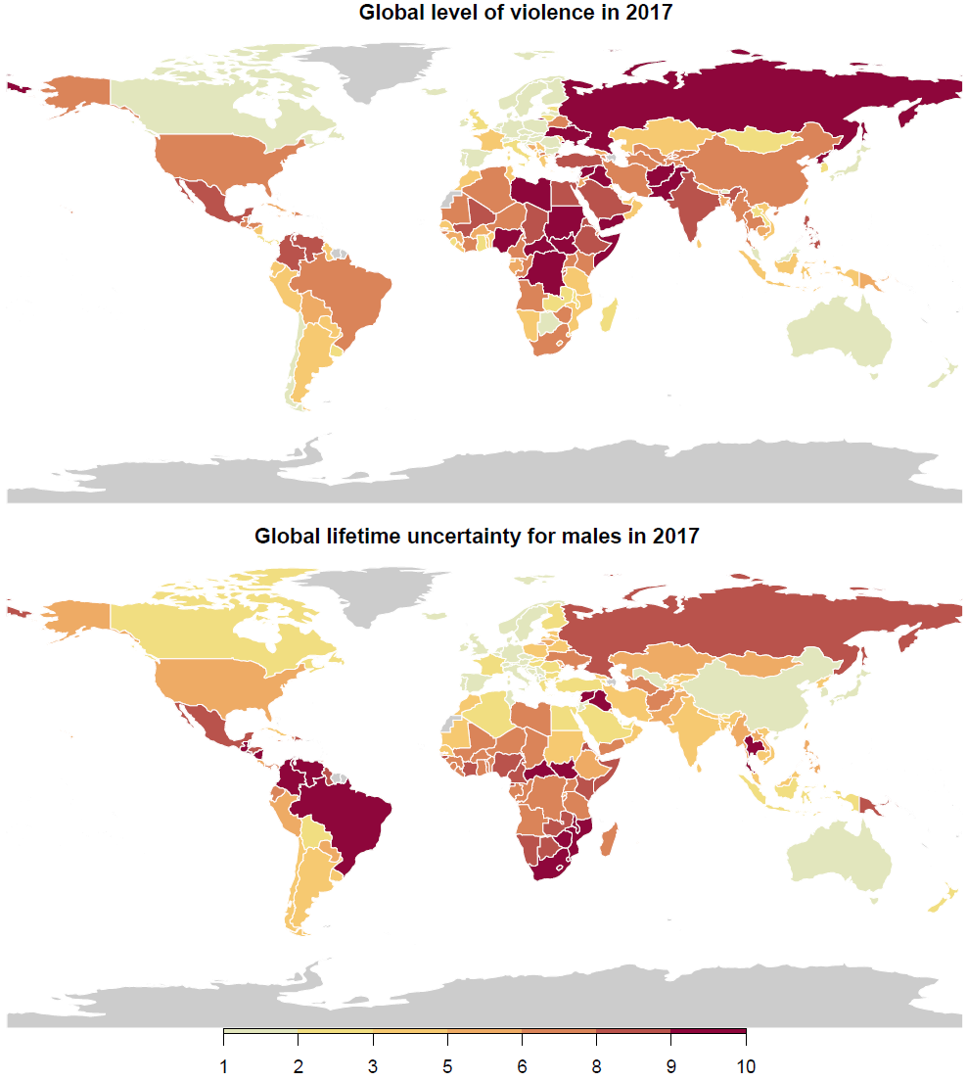

Peaceful countries all enjoy low lifetime uncertainty (Figure 2). The most violent instead tend to have higher lifetime uncertainty. Between 2008 and 2017, males and females living in the most dangerous countries showed a positive association with higher uncertainty in lifetime (correlation between GPI and life uncertainty is 0.51 and 0.44 for males and females, respectively). Moreover, the strong relationship between uncertainty about life and life expectancy suggests that those countries with high levels of violence experience lower levels of life expectancy than the peaceful ones.14 Indeed, males in Syria and Afghanistan had a life expectancy at age 10 of x and y years respectively, while the expected life span for males aged 10 in Iceland and New Zealand was of 70 years, a gap of almost 14 years. This is important because life uncertainty is a measure of how the length of life varies and the GPI measures the level of violence in a country. Although, in principle, the two indicators could be unrelated to each other –a peaceful country could suffer high lifetime uncertainty, while a violent country could show lower mortality and uncertainty in life – but this is not the case. The only country which displays a different behaviour is Israel. Here, although measures of violence are relatively high, life uncertainty is low.

As for gender differences, lifetime uncertainty is lower for females than for males. This advantage, however, is less associated with levels of violence (correlation of 0.44). We hypothesize that this difference results from higher mortality at young and working ages for males. This is usually referred to as the ‘young-mortality’ hump and it is an important explanatory factor of sex differences in mortality.36 For example, war related deaths are five times higher for men than for women, and homicide rates in Latin America are 10 times higher for men than for women.37 This highlights the importance of premature mortality on lifetime uncertainty in contexts of high violence.

**Figure 2 The relationship between lifetime uncertainty and the level of violence in a country by sex between 2008 and 2017.**

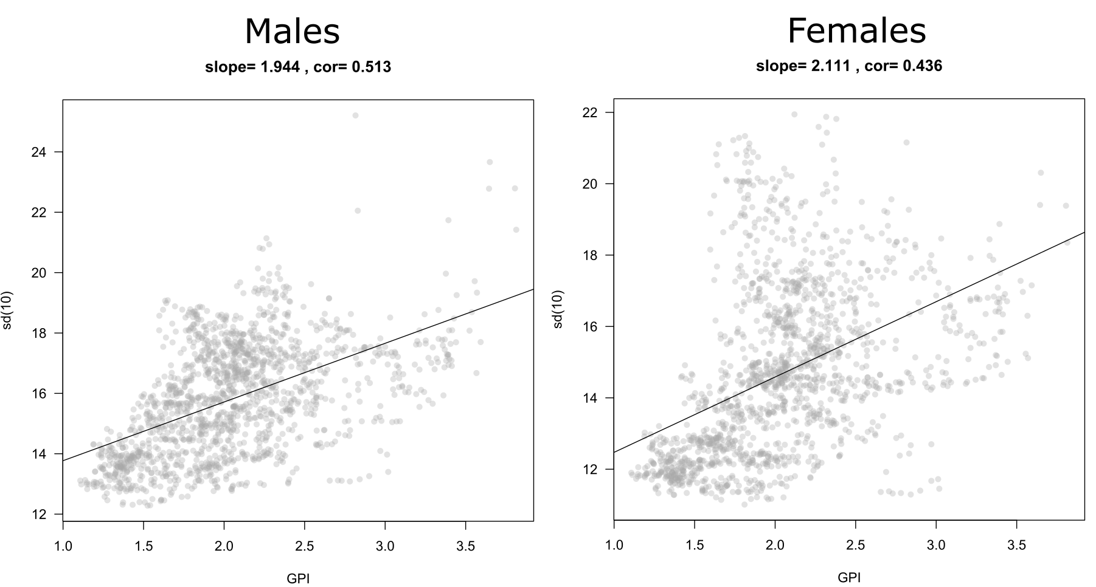

**Contribution of violent deaths to life uncertainty**

To test our hypothesis of the young mortality hump, we compared the 25 countries with the highest levels of violence in 2017 with the set of countries that ranked in the top-10 of the most peaceful in the period 2008-2017. The former group includes countries like Syria, Afghanistan, South Sudan, Iraq, Somalia, Colombia, Mexico and Venezuela. The latter, Iceland, New Zealand, Austria, Portugal and Denmark, among others. This strategy allowed us to identify the ages driving the difference in lifetime uncertainty between violent countries and more peaceful ones. Additionally, we were able to analyze the contribution of homicides, war-related, and other violent causes of death to lifetime uncertainty. These results, however, represent a lower bound as violent deaths are often underestimated and underreported, especially in high-level violent settings. For example, in Mexico and Venezuela, lack of data has made difficult for researchers to estimate the current level of homicides due to misclassification, underreported murders, and the increasing number of missing individuals.38 Equally, the collection of credible/accurate data is particularly difficult in besieged and remote areas in Syria and Yemen.

Compared to peaceful countries, the difference in lifespan uncertainty resulting from violence is remarkably high in the MENA region for both genders. For instance, it represents 91.4% and 55.7% of the difference for Syrian males and Iraqi females, respectively. In these countries, war-related violence contributes disproportionately to lifetime uncertainty as compared to homicides or other causes. This is especially true for men of young ages. For instance, lifetime uncertainty in Syria for men aged 20-25 contributes 2.5 years of life to the difference with the peaceful region, while in Iraq and Yemen it ranges between 1 and 1.3 years. Here, as well as in African settings like the Central African Republic, Somalia and South Sudan, the female advantage is visible across almost all age categories; yet, lifespan uncertainty due to war-related causes of death is higher for women approaching the start of their reproductive ages as compared to their male counterparts (about 0.8 for females and 0.5 years for males in Syria, 0.25 and 0.1 years in Yemen and 0.3 and 0.25 in Iraq). This suggests heightened vulnerability of adolescent females in contexts where war-related violence may come in the form of gender-related sexual violence.39-41

The contribution of homicides to lifetime uncertainty dominates in violent contexts of Latin America. Yet, age and gender-related patterns are substantially similar to countries experiencing war-type of violence. In Colombia and Mexico, lifespan uncertainty due to homicide deaths is particularly concentrated among men aged 20-35. In Venezuela, the contribution of homicides is manifested even at younger ages, with lifetime uncertainty due to homicides for men aged 15-20 approaching … years of life. The impact of homicides is substantially more visible among men, although these still account for about 21, 14 and 11 percent of the total causes of lifetime uncertainty among Colombian, Mexican and Venezuelan women, respectively.

Overall, this analysis shows that violence in the form of armed conflicts and interpersonal deaths has manifest importance in variation in lifespans. This impact on the unpredictability of life is overwhelmingly concentrated in young ages and predominantly influences lifespan uncertainty of men, confirming our hypothesis that gender differences are shaped by higher male violence-related mortality. It follows that countries with the lowest levels of lifespan uncertainty succeeded not only because of lower general levels of mortality at all ages, but also because deaths due to war or interpersonal violence in these contexts for both genders are almost inexistent (x and y per 100,000 for males and females, respectively [Tim?]).

**Perspectives**

Conflict and non-conflict armed violence are a phenomenon plaguing many regions of the world, with many of the crises erupted in the past decade remaining unresolved. This progressive fall in peacefulness is having impacts on individuals’ life chances and lifetime uncertainty.

MENA

[I think this paper deserves attention especially in terms of theory for MENA countries <https://www.jstor.org/stable/pdf/3877825.pdf?casa_token=vZcOwJfD1zAAAAAA:w6qPhb3CKs9DfXMOsZ93UV1VwrGA0PrbjNTLfdrgpMHyU3dDkrSw2etex4PijCFboydJ5PaoCSTtsO2mfa8CkettGuGNxsIi8Y8gT0JiOMZ50S8wDeXOLQ>]

In the MENA region, peace and social order have been sharply deteriorated by years of civil violence. Persistent internal conflicts and porous borders have rapidly created power vacuums and “safe heavens” for terrorist groups such as ISIS in Syria and Iraq, and Al-Qaida in Yemen.42,43 At the same time, the increasingly internationalization of these armed conflicts and the consequent external military support, peculiarly Syria and Yemen, have allowed warring factions to use highly sophisticated and more deadly weapons with huge collateral effects on civilians.31 Violence in the region has been further exacerbated by pre-existing widespread poverty, displacement and restrictions on livelihoods and increasing food insecurity.44 Such tremendous escalation in violence has substantially shaped lifetime uncertainty in these settings and contributed to the gap with more peaceful regions. In the MENA region, the contribution of war-related violence is remarkably evident among young men, who ostensibly bear more the direct mortality consequences of combats and military operations. Yet, from our analyses it also emerges that the breakdown of social stability due to conflict violence in this region influences also the lifespan uncertainty of adolescent women approaching their reproductive ages. This age-related differential vulnerability can be partly explained by pre-existing fundamental imbalances in gender relations at young ages in particular in the region.45 Structural patterns of disadvantage for women approaching their reproductive ages are likely to have been magnified in times and zones of conflict.[I like this form of violence as social determinant of health]

These findings make clear

[See Honduran females and femicide]

* The increase and high levels of homicide in Latin America.
* The relationship with life expectancy
* Differences between males and females
* The hump hypothesis
* Subjective survival probabilities and fear to crime.

**Acknowledgements:**

**Author contributions:**

**Competing interests:** Non-declared.

**Methods & Data [3000]**

**Data.** We used mortality estimates for 163 countries from the Global Burden of Disease Study.28 GBD is an observational epidemiological study widely used to analyse trends in mortality and morbidity from major diseases, injuries and risk factors in a global perspective. These data are provided in 5-year age intervals with the highest interval concentrating deaths above age 85. We focus on three main causes of death related to violence Table 1 for code of the International Classification of Diseases [ICD10]): 1) homicide, 2) other violence (mostly war, state, and terrorist), and 3) all other causes.

To measure the levels of violence (or peacefulness) we use the Global Peace Index (GPI). GPI has been systematically calculated in the period that we study 2008-2017.29 It ranks the 163 countries according to the level of peacefulness. It is based on 23 qualitative and quantitative indicators that measure the state of peace using three domains: the level of societal safety and security, the extent of ongoing domestic and international conflict, and the degree of militarization. It is the most comprehensive index at a global scale and, therefore, a primary source of this study. The R-code to get the data is available at [URL].

**Demographic methods.** To more accurately measure the age-at-death distributions for each country we ungrouped the 5-year age intervals to single ages and distributed the deaths above age 85 with the penalized composite model assuming that deaths follow a Poisson distribution and calculated age-specific mortality rates.46 We constructed life tables for each country, sex, and year following standard demographic techniques.47 From these, lifespan uncertainty conditional on surviving to age 10 were calculated.

To disentangle the effect of violent deaths we calculated life expectancy and lifespan uncertainty in absence of these following the cause-deleted life table methodology.47 Additionally, we decomposed the difference in lifespan uncertainty between violent countries and RPR using the linear integral model for decomposition.48 All procedures were done using the R software,49 and are fully reproducible from the public repository [URL].

**Life span uncertainty indicator.** Several indices, highly correlated, to measure lifespan uncertainty exist.35,50 We chose the standard deviation of longevity conditional on surviving to age 10. This indicator has the advantages of being widely used as dispersion indicator in statistics, easy to interpret, decomposable into age- and cause-specific components, and is expressed in years. In life table notation the standard deviation ($σ$) is given by

$$σ=\sqrt{\int_{10}^{ω}{{(x-e_{10})}^{2}f\left(x\right)\text{d}x}}. (1)$$

Where $f\left(x\right),e_{10}$ and $ω$ denote the age-at-death density function, life expectancy at age 10, and the open-aged interval (110+ in our case), respectively. We condition to age 10 to capture the onset of violent deaths, which [x%, Tim?] occur over this age, and because infant mortality conceals mortality dynamics of adult ages.51

**Robustness check with life disparity.** All figures were replicated using “life disparity” or average life lost. This indicator has been used in several lifespan uncertinty studies, including one focusing on homicide mortality. The indices differ in their sensitivity to changes in mortality and in properties and is measured in years, allowing a direct comparison with the standard deviation. While some variations in the levels of lifetime uncertainty were observed, the main results and conclusions of our study are supported.

**Robustness check conditioning on surviving to different ages.**

**Selection of violent countries and construction of the robust peaceful region (RPR).** We focus on the worst and best performers of GPI to compare the burden of violence on lifespan uncertainty. The “Best Performers” category includes all countries that ranked in the top ten over the period 2008-2017: Australia, Austria, Belgium, Canada, Switzerland, Czech Republic, Denmark, Finland, Ireland, Iceland, Japan, Norway, New Zealand, Portugal, Singapore, Slovenia and Sweden. The “Most Violent” category includes the 25 worst performers countries that scored a low or very low level of GPI in 2017. [Let’s create a table with both the peaceful, violent and life uncertainty levels, gpi] To have more robust comparisons of lifetime uncertainty between violent countries and a peaceful environment, we constructed a “Robust Peaceful Region” based on the best performers of GPI. It was determined by the weighted mean of age-specific death rates by sex of the Best Performers. The weights were constructed according to the instances each country appeared in the top ten.

**References [50]**

1 Abel, A. B. Precautionary saving and accidental bequests. *The American Economic Review* **75**, 777-791 (1985).

2 Eckstein, Z., Eichenbaum, M. & Peled, D. Uncertain lifetimes and the welfare enhancing properties of annuity markets and social security. *Journal of Public Economics* **26**, 303-326 (1985).

3 Barro, R. J. & Friedman, J. W. On uncertain lifetimes. *Journal of Political Economy* **85**, 843-849 (1977).

4 Caliendo, F. N., Gorry, A. & Slavov, S. Survival Ambiguity and Welfare. (National Bureau of Economic Research, 2017).

5 Chang, F.-R. Uncertain lifetimes, retirement and economic welfare. *Economica*, 215-232 (1991).

6 Firebaugh, G., Acciai, F., Noah, A. J., Prather, C. & Nau, C. Why lifespans are more variable among blacks than among whites in the United States. *Demography* **51**, 2025-2045 (2014).

7 Lariscy, J. T., Nau, C., Firebaugh, G. & Hummer, R. A. Hispanic-White differences in lifespan variability in the United States. *Demography* **53**, 215-239 (2016).

8 Sasson, I. Trends in life expectancy and lifespan variation by educational attainment: United States, 1990–2010. *Demography* **53**, 269-293 (2016).

9 van Raalte, A. A. *et al.* More variation in lifespan in lower educated groups: evidence from 10 European countries. *International Journal of Epidemiology*, dyr146 (2011).

10 van Raalte, A. A., Martikainen, P. & Myrskylä, M. Lifespan variation by occupational class: compression or stagnation over time? *Demography* **51**, 73-95 (2014).

11 van Raalte, A. A., Sasson, I. & Martikainen, P. The case for monitoring life-span inequality. *Science* **362**, 1002-1004 (2018).

12 Aburto, J. M. & Beltrán-Sánchez, H. Upsurge of Homicides and Its Impact on Life Expectancy and Life Span Inequality in Mexico, 2005–2015. *American journal of public health*, e1-e7 (2019).

13 Aburto, J. M. & van Raalte, A. Lifespan dispersion in times of life expectancy fluctuation: the case of Central and Eastern Europe. *Demography* **55**, 2071-2096 (2018).

14 Colchero, F. *et al.* The emergence of longevous populations. *Proceedings of the National Academy of Sciences* **113**, E7681-E7690 (2016).

15 Németh, L. Life expectancy versus lifespan inequality: a smudge or a clear relationship? *PloS one* **12**, e0185702 (2017).

16 Shkolnikov, V. M., Andreev, E. M., Zhang, Z., Oeppen, J. & Vaupel, J. W. Losses of expected lifetime in the United States and other developed countries: methods and empirical analyses. *Demography* **48**, 211-239 (2011).

17 Smits, J. & Monden, C. Length of life inequality around the globe. *Social Science & Medicine* **68**, 1114-1123 (2009).

18 Vaupel, J. W., Zhang, Z. & van Raalte, A. A. Life expectancy and disparity: an international comparison of life table data. *BMJ open* **1**, e000128 (2011).

19 Wilmoth, J. R. & Horiuchi, S. Rectangularization revisited: Variability of age at death within human populations. *Demography* **36**, 475-495 (1999).

20 Seligman, B., Greenberg, G. & Tuljapurkar, S. Equity and length of lifespan are not the same. *Proceedings of the National Academy of Sciences* **113**, 8420-8423 (2016).

21 Aburto, J. M., Wensink, M., van Raalte, A. & Lindahl-Jacobsen, R. Potential gains in life expectancy by reducing inequality of lifespans in Denmark: an international comparison and cause-of-death analysis. *BMC public health* **18**, 831 (2018).

22 Curiel, R. P. & Bishop, S. R. Fear of crime: the impact of different distributions of victimisation. *Palgrave Communications* **4**, 46 (2018).

23 Skogan, W. G. The impact of victimization on fear. *Crime & Delinquency* **33**, 135-154 (1987).

24 Canudas-Romo, V., Aburto, J. M., García-Guerrero, V. M. & Beltrán-Sánchez, H. Mexico's epidemic of violence and its public health significance on average length of life. *Journal of epidemiology and community health* **71**, 188-193 (2017).

25 Jackson, J. & Gray, E. Functional fear and public insecurities about crime. *The British Journal of Criminology* **50**, 1-22 (2009).

26 Ruijsbroek, A., Droomers, M., Groenewegen, P. P., Hardyns, W. & Stronks, K. Social safety, self-rated general health and physical activity: changes in area crime, area safety feelings and the role of social cohesion. *Health & place* **31**, 39-45 (2015).

27 Carro, D., Valera, S. & Vidal, T. Perceived insecurity in the public space: Personal, social and environmental variables. *Quality & Quantity* **44**, 303-314 (2010).

28 Institute for Health Metrics and Evaluation (IHME). *GBD Compare. Seattle, WA: IHME, University of Washington*, < <http://vizhub.healthdata.org/gbd-compare>> (2019).

29 Institute for Economics & Peace. *Global Peace Index 2018: Measuring Peace in a Complex World, Sydney*, <<http://visionofhumanity.org/reports>> (2019).

30 United Nations Office on Drugs Crime. *Global study on homicide 2013: trends, contexts, data*. (UNODC, 2013).

31 Guha-Sapir, D., Schlüter, B., Rodriguez-Llanes, J. M., Lillywhite, L. & Hicks, M. H.-R. Patterns of civilian and child deaths due to war-related violence in Syria: a comparative analysis from the Violation Documentation Center dataset, 2011–16. *The Lancet Global Health* **6**, e103-e110 (2018).

32 Burnham, G., Lafta, R., Doocy, S. & Roberts, L. Mortality after the 2003 invasion of Iraq: a cross-sectional cluster sample survey. *The Lancet* **368**, 1421-1428 (2006).

33 Rawaf, S. The 2003 Iraq war and avoidable death toll. *PLoS medicine* **10**, e1001532 (2013).

34 Aburto, J. M., Beltrán-Sánchez, H., García-Guerrero, V. M. & Canudas-Romo, V. Homicides in Mexico reversed life expectancy gains for men and slowed them for women, 2000–10. *Health Affairs* **35**, 88-95 (2016).

35 van Raalte, A. A. & Caswell, H. Perturbation analysis of indices of lifespan variability. *Demography* **50**, 1615-1640 (2013).

36 Remund, A., Camarda, C. G. & Riffe, T. A cause-of-death decomposition of young adult excess mortality. *Demography* **55**, 957-978 (2018).

37 Briceño-León, R., Villaveces, A. & Concha-Eastman, A. Understanding the uneven distribution of the incidence of homicide in Latin America. *International Journal of Epidemiology* **37**, 751-757 (2008).

38 Aburto, J. M., Riffe, T. & Canudas-Romo, V. Trends in avoidable mortality over the life course in Mexico, 1990–2015: a cross-sectional demographic analysis. *BMJ open* **8**, e022350 (2018).

39 Brown, C. Rape as a weapon of war in the Democratic Republic of the Congo. (2011).

40 Alcorn, T. Responding to sexual violence in armed conflict. *The Lancet* **383**, 2034-2037 (2014).

41 Vu, A. *et al.* The prevalence of sexual violence among female refugees in complex humanitarian emergencies: a systematic review and meta-analysis. *PLoS currents* **6** (2014).

42 Gerges, F. A. *Isis: A History*. (Princeton University Press, 2017).

43 Clausen, M.-L. Understanding the crisis in Yemen: Evaluating competing narratives. *The International Spectator* **50**, 16-29 (2015).

44 Loewenberg, S. Conflicts worsen global hunger crisis. *The Lancet* **386**, 1719-1721 (2015).

45 Alsaba, K. & Kapilashrami, A. Understanding women’s experience of violence and the political economy of gender in conflict: the case of Syria. *Reproductive health matters* **24**, 5-17 (2016).

46 Rizzi, S. *et al.* How to estimate mortality trends from grouped vital statistics. *International journal of epidemiology* (2018).

47 Preston, S. H., Heuveline, P. & Guillot, M. *Demography. Measuring and Modeling Population Processes*. (Blackwell, 2001).

48 Horiuchi, S., Wilmoth, J. R. & Pletcher, S. D. A decomposition method based on a model of continuous change. *Demography* **45**, 785-801 (2008).

49 Team, R. C. (2014).

50 Wrycza, T. F., Missov, T. I. & Baudisch, A. Quantifying the shape of aging. *PloS one* **10**, e0119163 (2015).

51 Edwards, R. D. & Tuljapurkar, S. Inequality in life spans and a new perspective on mortality convergence across industrialized countries. *Population and Development Review* **31**, 645-674 (2005).